Q1) Design an algorithm and draw a flowchart to swap the values of two variables entered by user.
- Flowchart:
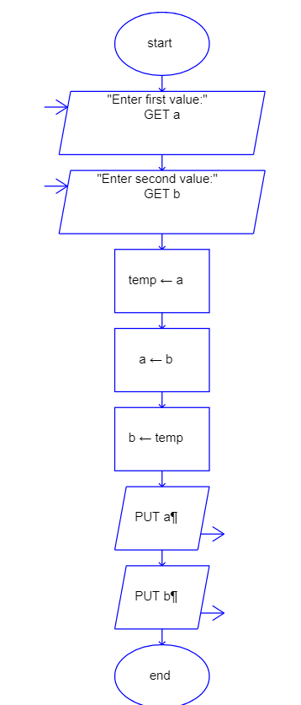
Algorithm:
Input: Any two numbers
Procedure:
Start
Step-1: Read two values from user into the variables a and b.
Step-2: Initialize the variable temp to a.
Step-3: Initialize the variable a to b.
Step-4: Initialize the variable b to temp.
Step-5: Print a and b.

Q2) Draw a flowchart and design an algorithm to compute factorial of any number entered by
user.
- Flowchart:
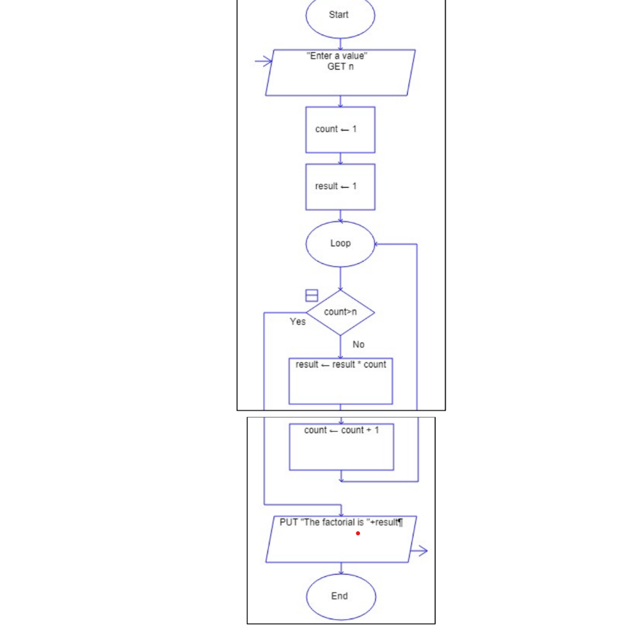
Algorithm
Input: A number
Procedure:
Step 1: Start
Step 2: initialize variable count to 1
Step 3: initialize variable result to 1
Step 4: repeat until count > n
Step 4.1: result = result * count
Step 4.2: count = count + 1
Step 5: Display value of ‘result’
Step 6: End
Output: Factorial of the number

Q3) Develop an algorithm and flowchart to reverse the digits of an integer entered by user.
- Flowchart:
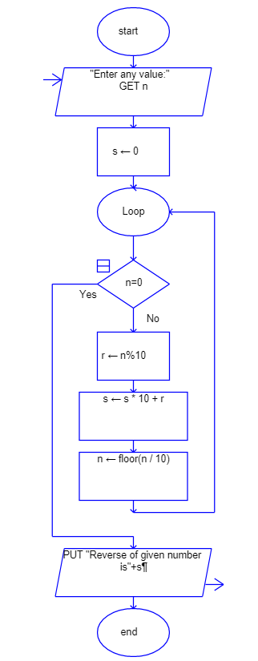
Algorithm:
Input: 1 number.
Procedure:
Start
Step-1: Read a value from user into the variable n.
Step-2: Initialize the variable s to 0.
Step-3: Repeat until the value of n becomes 0.
Step-3.1: r=n%10
Step-3.2: s=s*10+r
Step-3.3: n=floor(n/10)
End
Output: Reverse of given number.
Q4) Develop an algorithm and flowchart to compute the greatest common divisor of two given integers.
A) Flowchart:
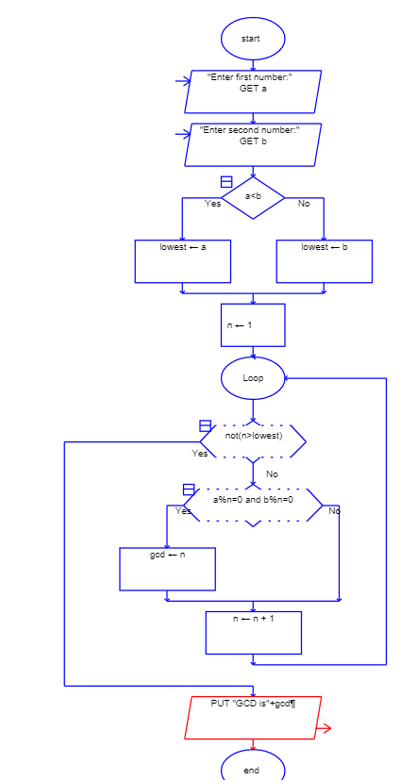
Algorithm:
Input: Two integer values.
Procedure:
Start
Step-1: Read two integer values from user into variable n1 and n2.
Step-2: If n1<n2
Least=n1
Else:
Least=n2
Step-3: Repeat x from 1 to least
Step-3.1: If n1 and n2 are divisible by x
gcd=x
Step-4: Display variable gcd
End
Output: Greatest common divisor.
Q5) Develop a python program to check whether given year is leap year or not.
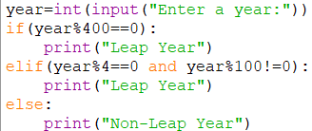
Q6) Design a python program that prints numbers from “start” to “end” using while loop, where “start” and “end” values are entered by user.
A)
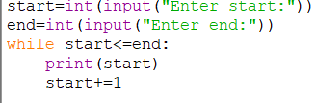
Q7) Write a python program that prints multiplication table of any number entered by user.
Allow the user to specify the table size also.
A)
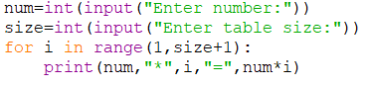
Q8)Write a python program to check whether given number is prime or not.
Q9) Design a python program that takes a sentence as input and prints the first half and second half separately.
A)
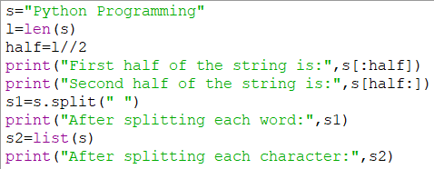
Q10) Develop a python program that processes a paragraph of text, counting the number of words, finding the longest word, and converting the text to title case.
A)
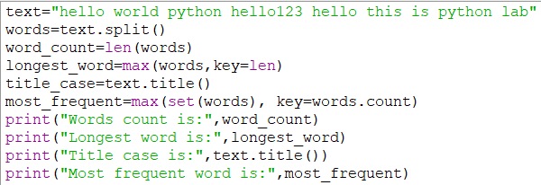
Q11) Design a python program to implement bubble sort algorithm that sorts a list of item
quantities entered by the user.
A)
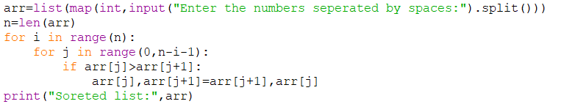
Q12) Design a python program to implement selection sort algorithm that sorts a list of item quantities entered by the user.

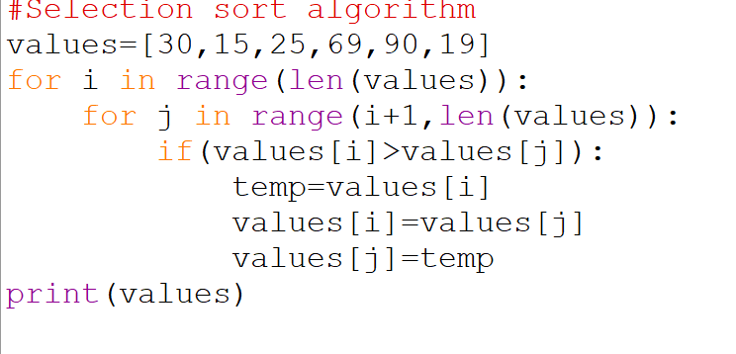
Q13) Perform set operations union,intersection and difference with the help of a python program.
A)
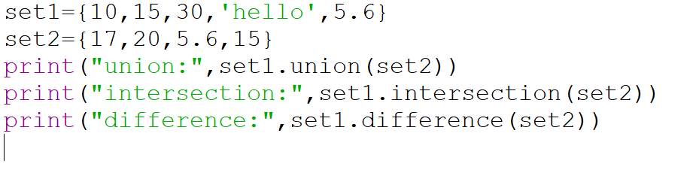
Q14)Create a python program to generate list of squares of even numbers between 1,20.
A)
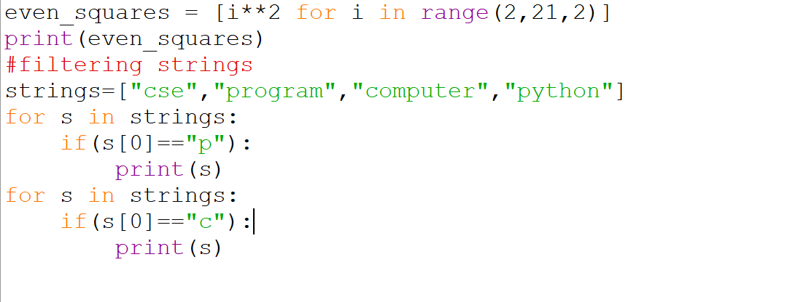

Q15)Create a program that models a library system using nested dictionaries.include functionality to list books by genre.
A)
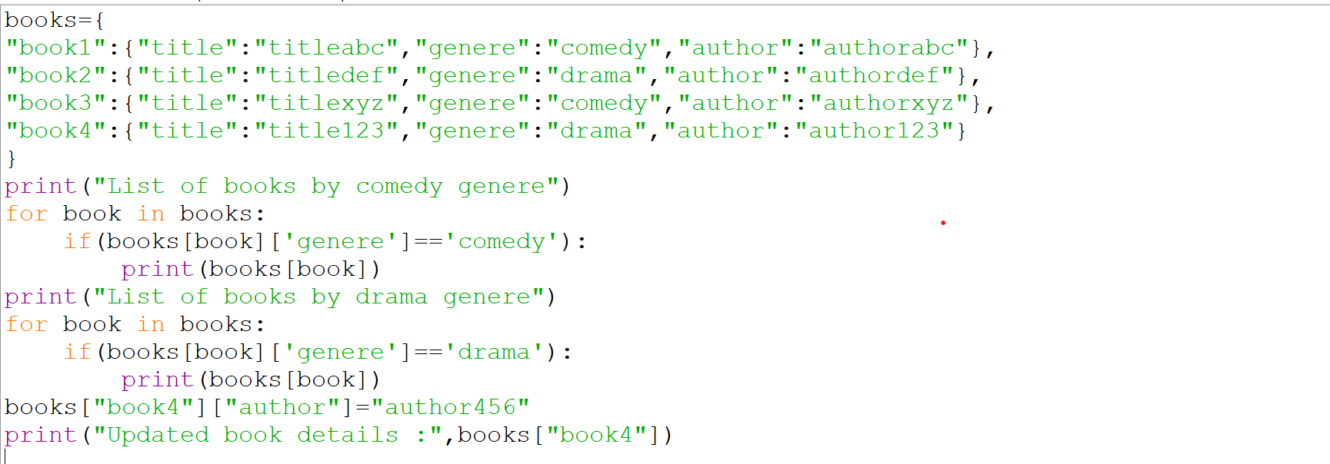
Q16)Develop a program to demonstrate how to (i) add and remove elements from a list (ii) accessing elements in tuple.
A)
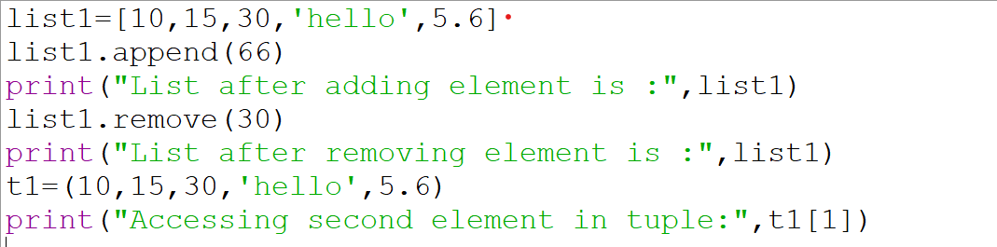
Q17)Design a python program to find factorial of a given number using recursion.
A)
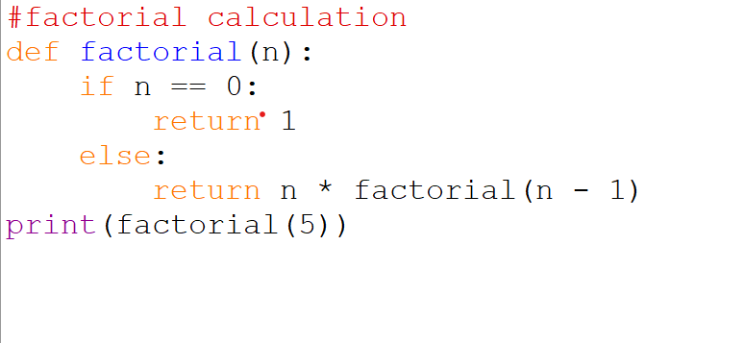
Q18)Explain the concept of binary search on a list of values with an example program
A)

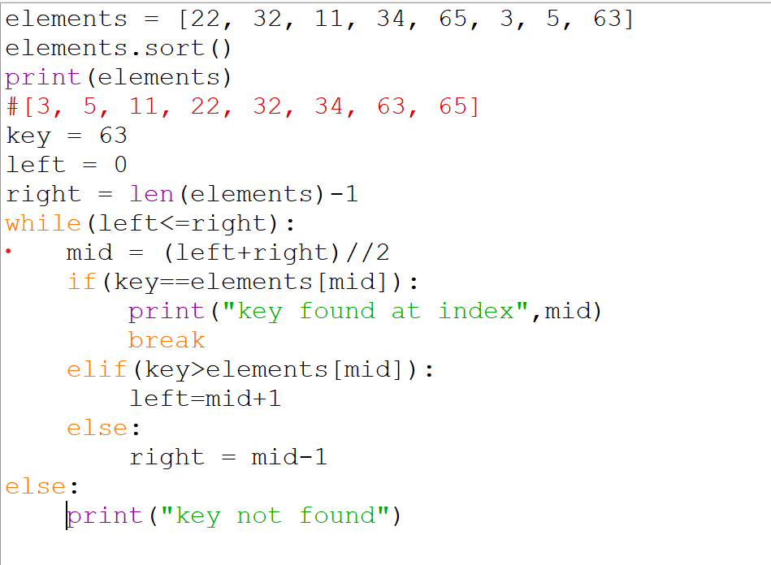

Q19)Design a python program to find sum of natural numbers upto n using recursion.
A)

Q20)Explain the concept of linear search on a list of values with an example program.
A)